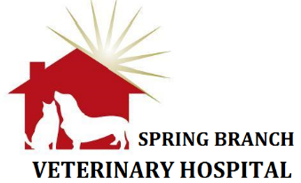

ADMISSION AGREEMENT

Medical Information
Please keep in mind that that Spring Branch Veterinary Hospital is an animal hospital that provides inpatient and grooming services. To keep all of our patients as healthy as possible, we require all pets to be current on vaccinations and recommend that pets have had a recent fecal sample to check for intestinal parasites.

Vaccines: For your convenience, your pet’s vaccines can be updated during their stay with us.
Dogs need to be current on rabies, distemper / parvo, and bordetella vaccinations,
Cats need to be current on feline rabies and distemper.

External Parasites: For the welfare of all of our patients, pets will be checked for fleas and/or ticks and treated as necessary at your expense.

Illness: I understand that any problems and/or illnesses that develop with my pet will be treated as deemed by the veterinarian, and I will assume full responsibility for the treatment expense involved.

The practice will not be held liable for problems that develop provided reasonable care and precautions are followed. I understand that I am responsible for payment of services that I or a designated agent have requested or authorized.

Your electronic signature constitutes your authorization and agreement to abide by the information stated above. At your request, you may sign with a paper signature in lieu of an electronic signature.

Signature/s/______________________________ _________ Date_________________

Megan Hughes, DVM Jessica Baas, DVM Kelsey Smith, DVM Robert Duncan, DVM Virginia Nell Duncan, DVM

